4.0 Twitch and Strategic Skills

There was a choice between strategic and twitch skills as premises for the games. It was decided that the game would be a bomb defusing game, implementing ideas pushed for strategic skillsets.

4.1 Materials

* The gameboard
* Clipper
* Bomb defusal manual
* Timer

4.2 Rules

* Designate a player to defuse the bomb and another to read the manual
* Player defusing must not look at the manual
* Manual holder can only talk to give instructions
* Set the timer to one minute
* Defuser must cut all correct wires to win
* If the wrong wire is cut it is an instant loss.

4.3 Gameplay

Two players are needed to play this game. At the start of the game, players must designate roles between them. One player can look at the bomb and the other will have the manual on how to defuse the bomb.

Every bomb has two wires that require cutting. During the game, both players are not allowed to look at each other and can only communicate verbally. The player in charge of the manual will relay the instructions written on the manual to their partner, while the player with the bomb, must follow the instructions being said in order to know which coloured wires to cut and the order they have to be cut in. Players have one minute, which should be set on the timer, to defuse the bomb so they can win.

If players run out of time or they fail to cut the right wire, whether out of order or the wrong wire, then it results in an instant loss.

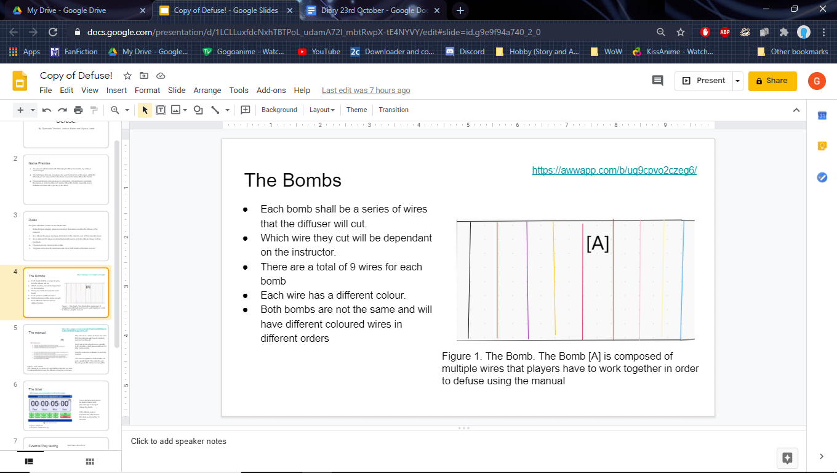

Figure 1. Gameboard. The gameboard [A] was made with the idea that the bomb would have multi coloured wires where two would need to be cut.

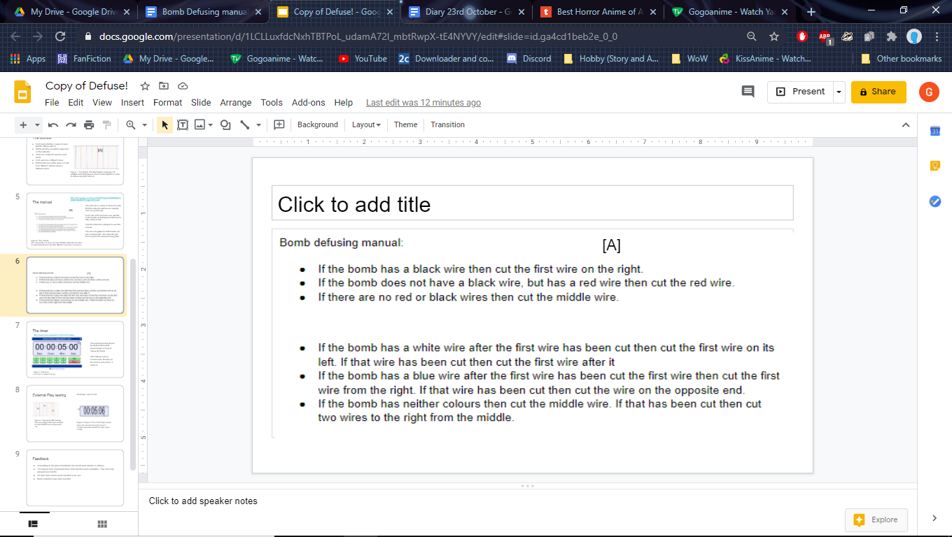

Figure 2. Manual. Players were provided the manual [A] this will direct them on which order the wires had to be cut.

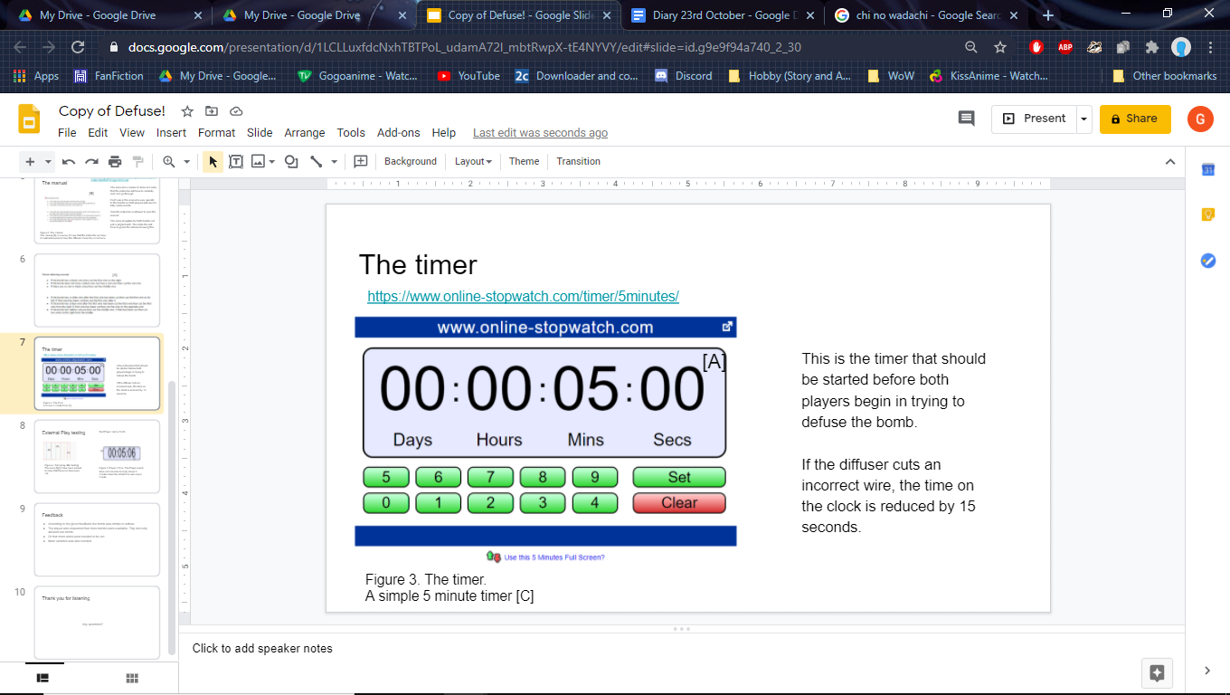

Figure 3. Timer. This is an example of a timer that players can use. A minute should be placed on the clock [A] before the game starts.

4.4 Test Play

During the test play, it was revealed that the game was too quick and as part of the feedback, the player suggested more bombs were available, since only one was allowed to be played, or that more wires were available to be cut. Another critique of the game was that it was just too simple, because all of the wires were just next to each other. To improve on this aspect, it was decided that wires should be intertwined to confuse players more.

4.5 Reflection

During the beginning of the task, it was quickly decided on which of the two was going to be made. Once the decision was made, individual roles were given to each member which led to having enough time implementing everything that was desired into the game and test playing it with an external player. Furthermore, the presentation managed to come out fully completed by the end, with only a few minor tweaks needed to be implemented, like the labelling with figures.

As for personal performance, eye contact has certainly improved since the last face to face presentation, managing to maintain it with the audience for most of the time, only needing to take glances at the slides.

While time management had greatly improved with the addition of the test play, it still requires some refinement because even though external test play had been done, time had run out in implementing the feedback given. Finally, the presentation needed some changes, because fonts were inconsistent with some being too small.